## 

## **Practical-9 & 10**

**Student Name:** Gauri Prabhakar **UID:** 18BCS6201

**Branch:** 18AITAIML-2 **Section/Group:** B

**Semester:** 7 **Date of Performance:** 16th November, 2021

**Subject Name:** Computer Vision Lab **Subject Code:** CSF - 432

# Aim/Overview of the practical:

To study the YOLO (You Only Look Once) state of the art object detection algorithm. Write various phases of implementation.

To study Pedestrian, car, bus, truck, etc. detection from a video (category n- problem) using YOLO.

# Task to be done:

To study the YOLO (You Only Look Once) state of the art object detection algorithm. Write various phases of implementation.

To study Pedestrian, car, bus, truck, etc. detection from a video (category n- problem) using YOLO.

# Steps to be followed:

1. Importing necessary modules.
2. Creating a variable to store the video using the '.VideoCapture()' function.
3. Defining parameters.
4. Writing 'coco.names' to the list 'classFile'.
5. Returning the length of the list.
6. Loading the configuration files and weights.
7. Asking network to use specific computation back-end where it is supported.
8. Defining a function to implement YOLO.
9. Loading the shape of the image into the variables.
10. Printing the shape of the image.
11. Declaring the confidence.
12. Declaring the list to store classIDs.
13. Declaring the list to store confidence.
14. Looping to implement YOLO.
15. Looping through indices.
16. Setting condition to receive input and apply YOLO.
17. Capturing the video frame by frame using the '.read()' method.
18. Rendering the video with effective face tracking to the console by using the function '.imshow()'.
19. Setting up '.waitkey()' to wait for a specific time until any key is pressed and break the loop.
20. '.waitkey(1)' displays a frame for 1ms after which it moves to the next frame in the video.
21. Setting 'x' as the quitting button.
22. Releasing the variable/object 'cap'.
23. **Result/Output/Writing Summary:**

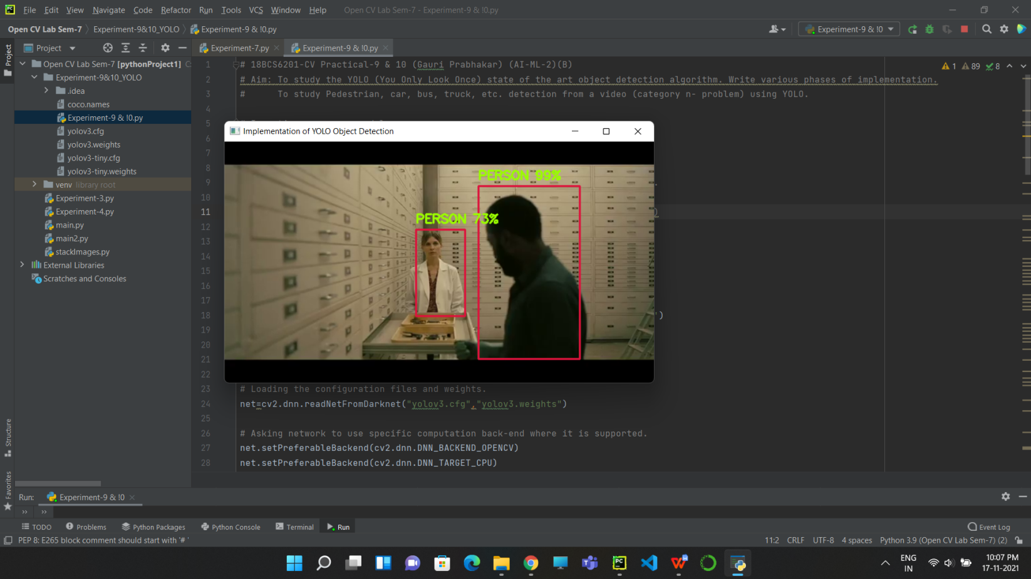

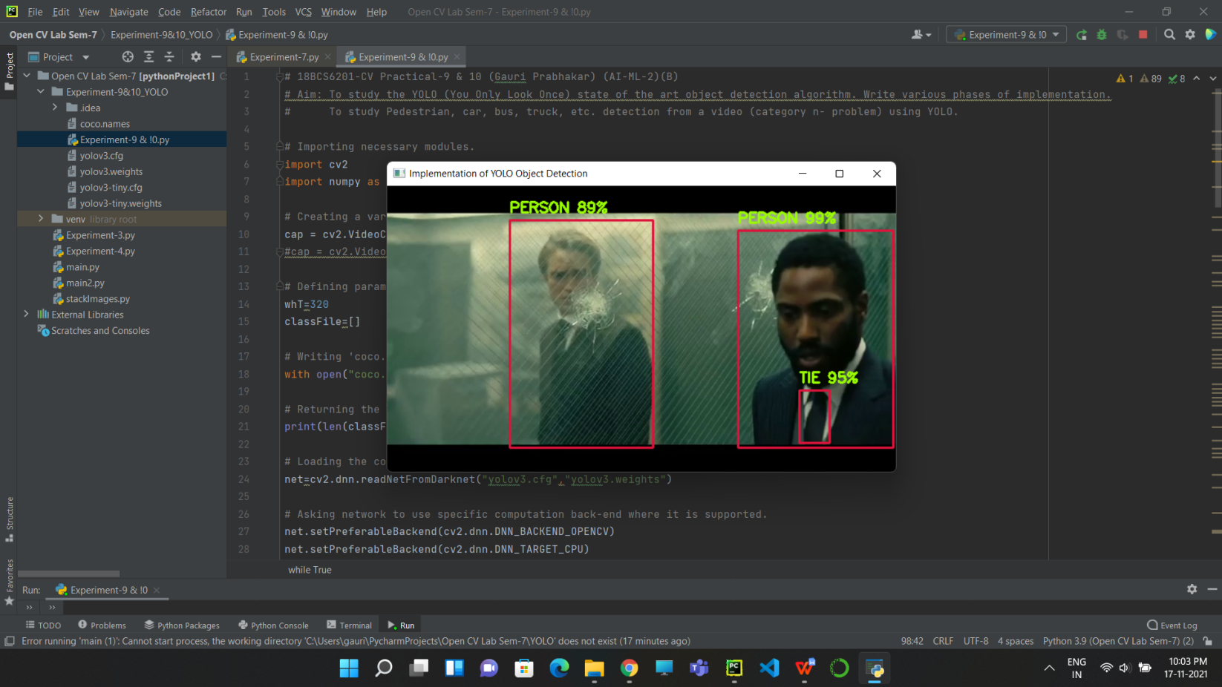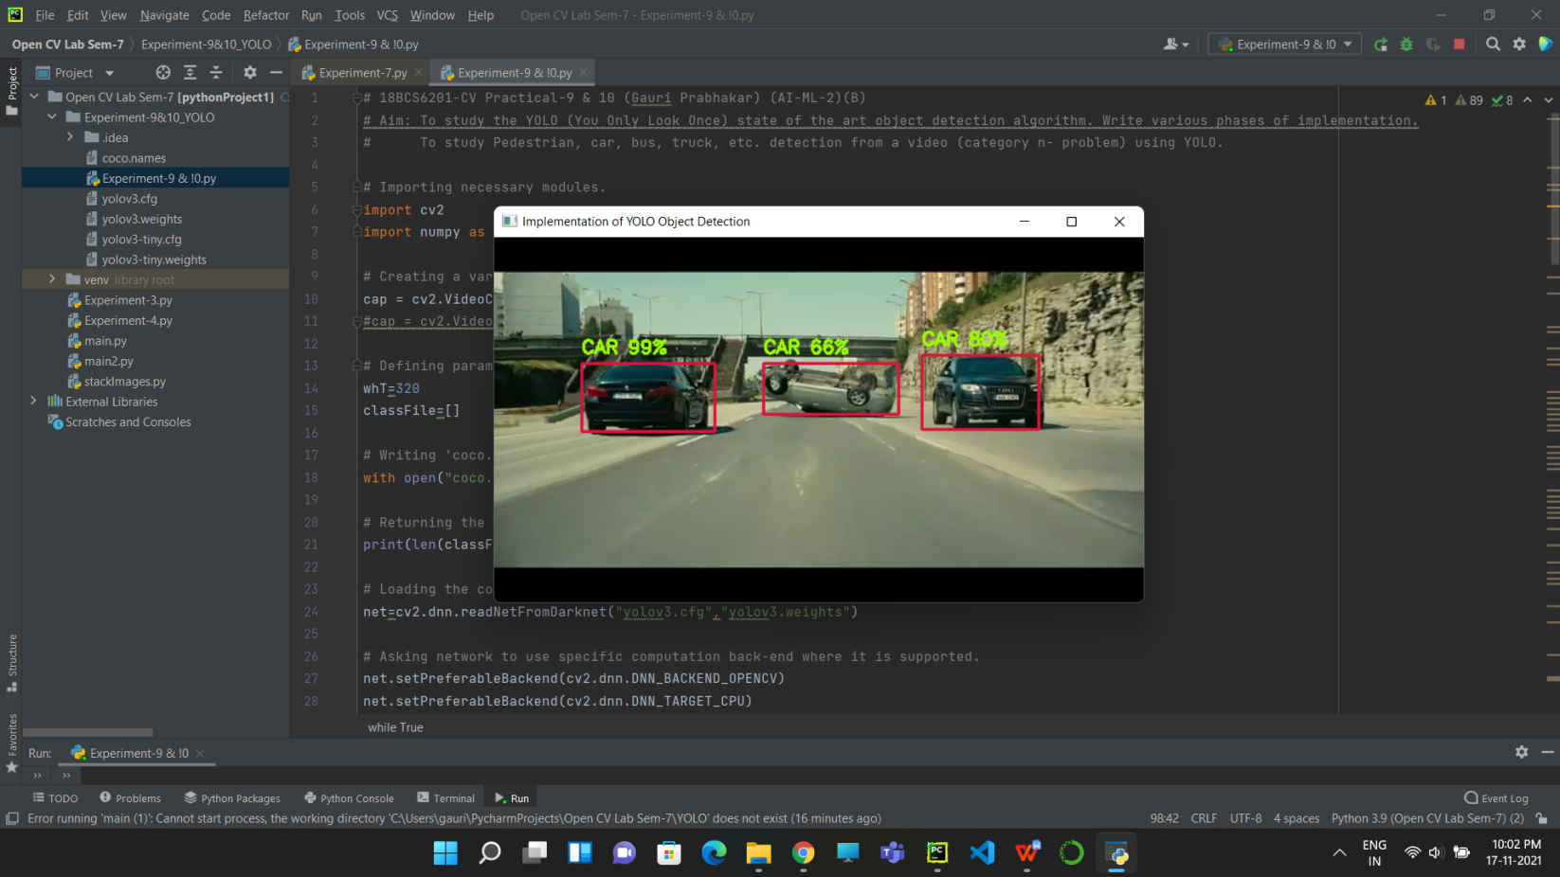

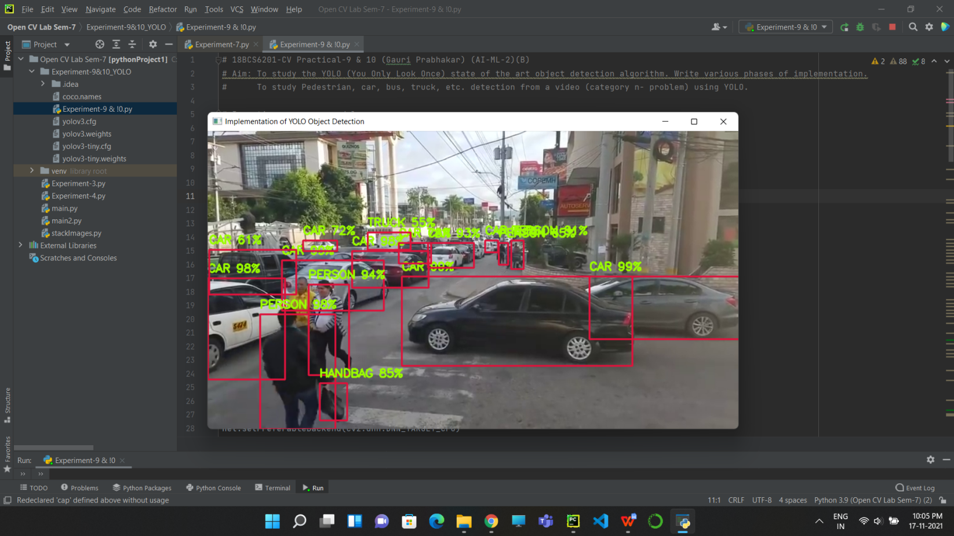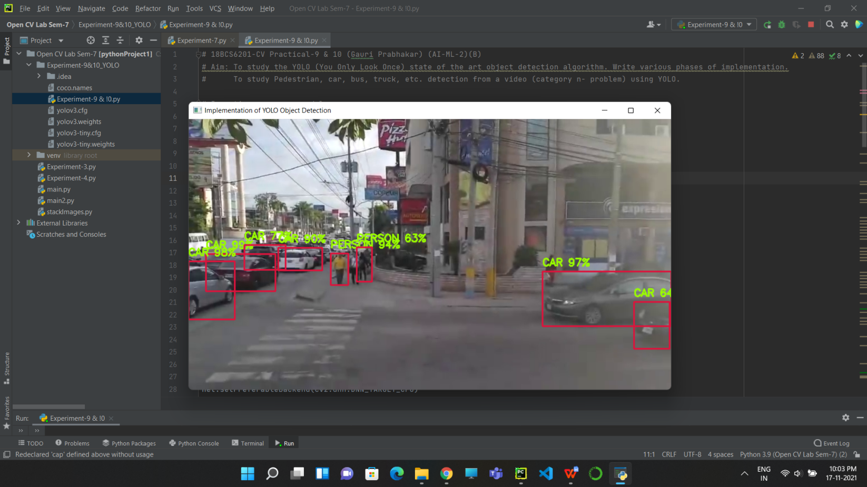

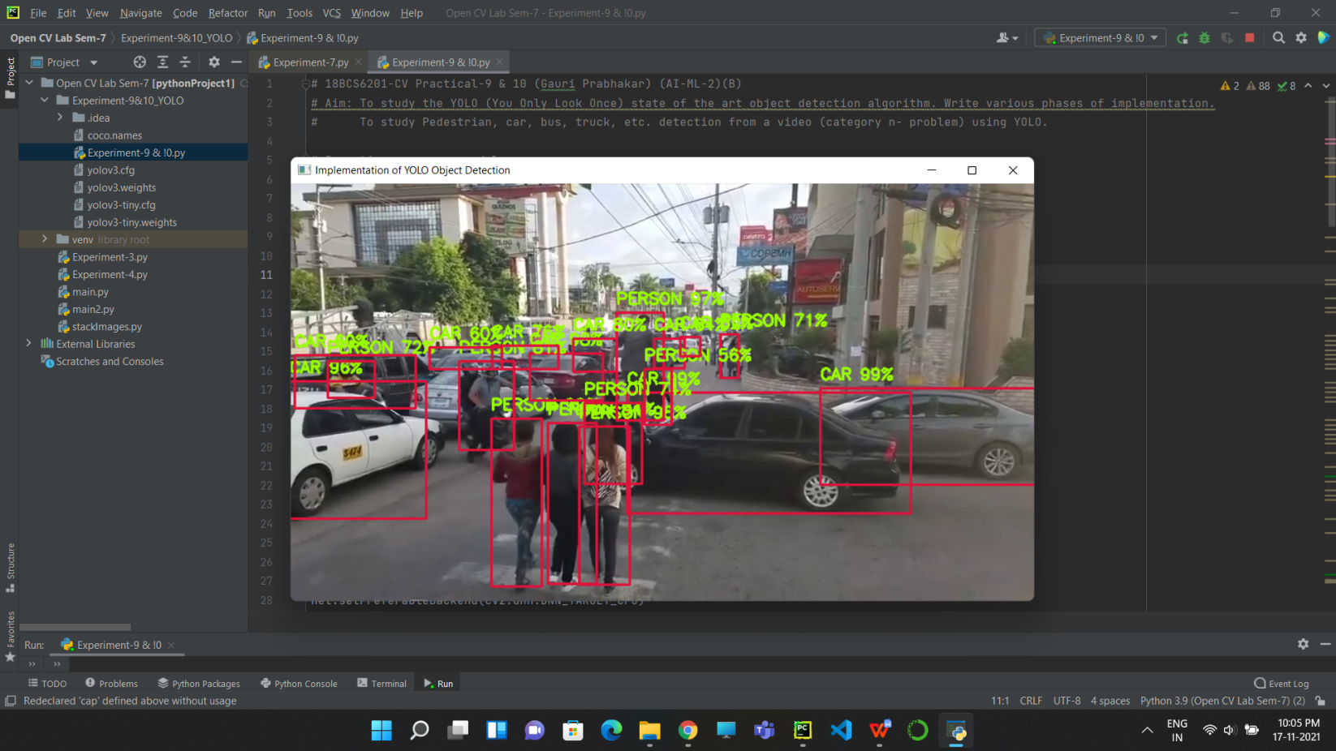

# Learning outcomes (What I have learnt):

* Open CV modules.
* YOLO implementation.
* Detect objects and displaying bounding box around the objects.
* Successfully implemented Object Detection on a saved image.
* Highlighting key points.
* Successfully tracked pedestrians, objects, cars, tie, etc.

**Evaluation Grid (To be created as per the SOP and Assessment guidelines by the faculty):**

|  |  |  |  |
| --- | --- | --- | --- |
| Sr. No. | Parameters | Marks Obtained | Maximum Marks |
| 1. |  |  |  |
| 2. |  |  |  |
| 3. |  |  |  |